SPAIN – ENJOY ITS “FIESTAS” & “SIESTAS”

Spain is one of the best “sun and sea destination” in Europe.
It is a unique melting pot of culture, art and music where you will find one of the world’s most vibrant musical expressions – the “Flamenco” and home to some of the most visited monuments in Europe. Try the Spanish cuisine and delicacies – the mouth-watering “tapas” along with one of their finest wines.

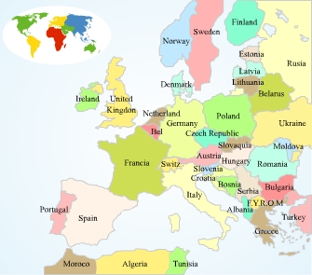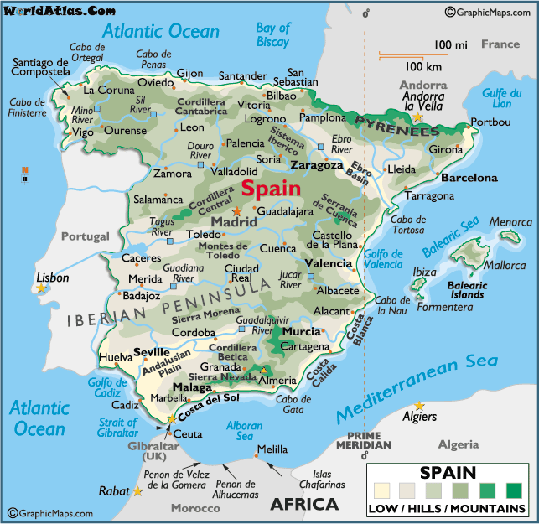

LOCATION :
Located on the Iberian Peninsula, The country is bordered by Portugal to the west, with France, and tiny Andorra, to the north. The British territory of Gibraltar is at Spain's southern tip. There are also Spanish enclaves off the North African coast of Morocco. Spain has a Mediterranean coast to east and south while the Atlantic washes the Northwest edge of the country. The major Spanish island groups are the Balearics, off the East Coast, and the Canaries, which are in the Atlantic off the coast of Africa.

Important Cities :

- Madrid is the Capital of Spain and lies in the Centre.
- Another very imp. City after Madrid is Barcelona in the North East, which is in the coastal region and known for its innovative architecture.
- If you are looking for a beach holiday, and are starting your journey from Barcelona, we would recommend you to visit Valencia, Alicante on Spains Eastern coast famous for its fiestas, food, year round weather. Ibitza and Palma Mallorca in the Balearic islands are also very well known.
- Down South, we have the very famous costa del sol region which needs no introduction. There is Malaga and marbella, well known for their resorts, good beaches and night life.
- Then we have Seville, Granada, and Cordoba which are world heritage sites and were ancient kingdoms during their times
- Toledo, just an hour away from Madrid, has been a natural fortess and speaks about its historical times. For clients staying for 3N in Madrid, we do recommend a full day excursion to Toledo.

VISA The visa is to be obtained prior to arrival in the country

HOW TO GET THERE :
International Airport : Madrid and Barcelona are 2 International gateways into Spain and serve as hubs to connect to all the other major parts of Spain.

Quite a few European Airlines fly to Madrid/Barcelona via their home country. Qatar Airways flies to Madrid and Barcelona via Doha

GETTING AROUND :
Air : It is possible to get internal flights within mainland Spain, although the most commonly used routes are those to the Balearic and Canary Islands. Good rates are often available to fly to the two island groups from within Spain.
Iberia, Spanair and Air Europa operate an extensive network of internal flights from the major airports.

Train : Spain has a very efficient rail system network. From any point in Europe, Spain is accessible by the Eurail network.
There’s one bullet train, the AVE, from Madrid to Seville and high-speed trains (Talgo) are widely available all over Spain.

Ferry : Spain is also served by a number of sea liners between the mainland and into the islands,as well as international routes connecting Spain with countries such as France, Morocco and Tunisia

Bus : The bus network is a lot more extensive than the rail network, and the prices (around EUR5.25 per 100km) are certainly easier to work out. Although a number of companies run buses in Spain, as a rule the buses themselves are uniformly comfortable and well maintained.

Distances (by train) :
From | To | No. of Hours
Madrid | Barcelona | 5 hrs
Madrid | Toledo | 1 hr.
Madrid | Valencia | 3 hrs. 30 mins.
Madrid | Cordoba | 2 hrs.
Madrid | Seville | 2 hrs. 30 mins.
Madrid | Malaga | 5 hrs.
Madrid | Granada | 6 hrs.

From | To | No. of Hours
Cordoba | Seville | 2 hrs
Cordoba | Malaga | 1 hr.
Cordoba | Granda | 2 hrs. 30 mins.

From | To | No. of Hours
Seville | Granada | 2 hrs 30 mins.
Seville | Malaga | 2 hrs 30 mins
Malaga | Granada | 2 hrs
Barcelona | Valencia | 3 hrs. 30 mins.

Barcelona to other cities is 7/8 hrs. journey hence it is recommended to take overnight trains.

CURRENCY :
The currency is Euro (EUR). The national central bank will exchange Peseta banknotes and coins indefinitely.

BUISNESS :
Shops are generally open between the following hours and closed during siesta:
Morning hours | 09h00/10h00 - 13h00/13h30
Siesta | 13h00/13h30 - 16h00/17h00
Afternoon hours | 16h00/17h00 - 20h00/21h00
Shops are often closed on Saturday afternoon and/or Sundays
CLIMATE :
The ideal months to visit are May, June and September (plus April and October in the south). That said, there's decent weather in some parts of Spain virtually year-round.
Temperatures vary from 21-29 degrees in the main cities of Madrid and Barcelona and 17-24 degrees in places like Toledo, Valencia, Granada and Sevilla.
CLOTHING :
In the summer months (June, July & August), wear light cottons and casuals. During the winter months in central Spain, a warm overcoat and gloves will be needed to protect you from sometimes fierce cold and winds
TIME :
Mainland Spain is 3 hours 30 minutes behind India, during Summers from March to October and 4 hours 30 minutes behind India, during Winters from November to February
ELECTRICITY :
Electricity supply is 220 volts throughout Spain with 2 pin wall sockets. It's recommended that you purchase your electrical plug adapter from the international airport that you are flying from rather than an electrical store in Barcelona.
DIALLING CODE :
International dialling code: | 39
Area codes: | Madrid: 91, Barcelona: 93, Malaga: 95, Alicante: 96, Seville: 95

TIPS :
Service is generally included in your restaurant bill. An additional tip of 5-10% is customary in bars, restaurants, hotels and taxis.

LANGUAGE :
Spanish is the official language spoken in the Country. English is the first foreign language in Spain.

INFORMATIVE WEBSITE :
www.spain.info

CITIES :

MADRID :
Madrid, Spain's capital, is a cosmopolitan city and the centre for economics, finance, administration and services.It is Europe’s highest capital city (at 2000 feet above sea level) and one of the liveliest and friendliest cities.It is also the hub of the Spanish railway network, serving international destinations like Paris and Madrid with long-distance, high-speed trains. It is also home to the most prestigious flamenco dance festivals

Accomodation Options in Madrid :
Central hotels tend towards the top of the market. If you want to be near the Prado and the Thyssen-Bornemisza museums, it would be hard to beat one of the sumptuous hotels in central Plaza Canovas del Castillos, right in the heart of the city, and close to some of Madrid's best shops, bars and restaurants.
Alternatively you can find more reasonably priced accommodation around the train station. The Husa Paseo del Arte is a brand new four star hotel located at the famous art triangle and just a stroll away from the city's buzzing nightlife. The stylish interior befits its location - with artwork adorning the walls in many of the public areas. Close by and one of Madrid's top hotels is the Gran Hotel Canaries, which overlooks the beautiful Neptuno Square. Accommodation is classical and luxurious, and its location unbeatable.

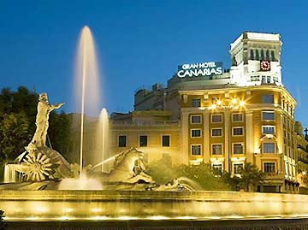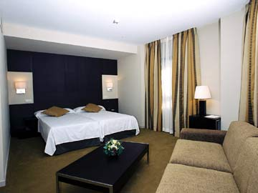

Must-Sees :
Puerta Del Sol :
The Plaza Puerta del Sol, is the historical Centre of Madrid
This bustling, centrally located square is one of the city's most lively places.
Now the heart of Madrid's historic center, this site used to be on the eastern border of the city. The plaza's name originates from the eastern city gate located here in the 15th century. The gate was probably called after a sun drawn on it, hence the name Puerta del Sol or 'Sun Gate'. The current semi-oval square was created in the 19th
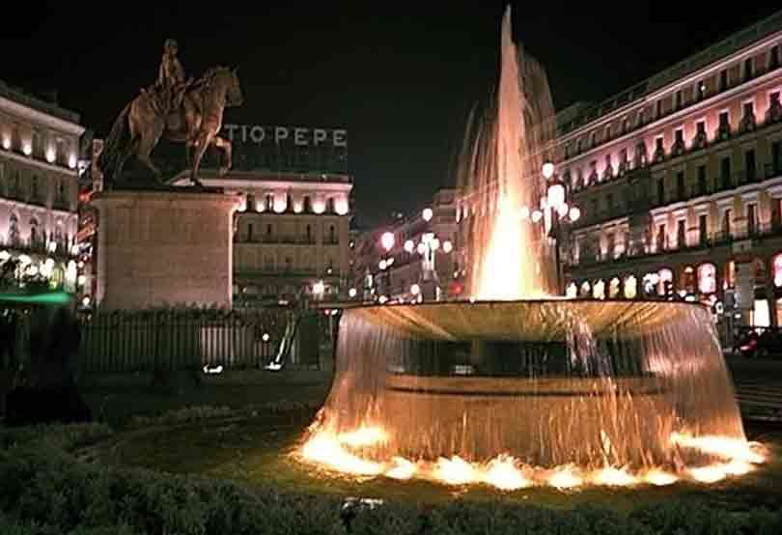
century.

The Fountain in the Plaza de Cibeles
Surrounded by some of the city’s most important monuments, it has become an important symbol of Madrid.

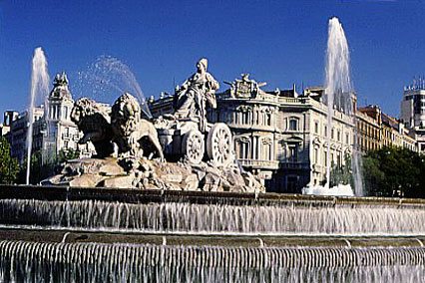

Prado Museum :
Art and culture are central to Madrid life. The city has 73 museums that cover all fields of human knowledge
The Prado Museum is one of the world's greatest art galleries and houses over 8600 canvases.

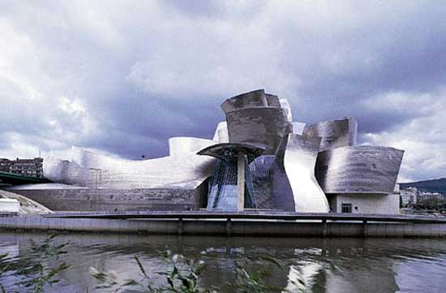

Royal Palace :
This was the official residence of the King and Queen of Spain till 1931 and now used for numerous important acts and events.
Few European royal residences still show the splendour of Madrid's Royal Palace. Its majestic rooms contain important artistic treasures and continue to witness historic events. Magnificent and resplendent, rises in the heart of the nation's capital on an exceptional spot offering extraordinary views of the mountains of Madrid.

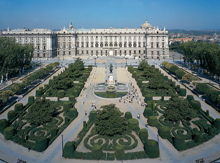

BARCELONA :
Surrounded by the Pyranees Mountains, Barcelona belongs to the Catalonia region and is an excellent Mediterranean metropolis. It is must visit for the Architectural buffs as it boasts of amazing architectural monuments and Cathedrals. It houses some of the world-class museums including Museu Picasso. Fine Food, Fashion, opera. Nightlife, street theatre, art.. Barcelona is all of this and more, a city that holds surprises for every visitor.

Accomodation Options in Barcelona :
An obviously convenient area to stay for tourists is anywhere along Las Ramblas. The tree-lined streets and lively buskers create a delightful ambience that gives an immediate flavour of the city to recently arrived visitors. Naturally rooms along here are at a premium and you might have to settle for something just off the main thoroughfare. Be aware that Las Ramblas itself remains lively all night, and if you need something quieter you should look elsewhere. There are plenty of private hotels in the narrow streets and secluded squares of the old town. The Eixample district is a bit less central but is the location of the Sagrada Familia, Gaudi's famously unfinished cathedral, as well as Casa Mila, the distinctive town house designed by the artist. Hotels here are more reasonably priced than those on Las Ramblas, a couple of options include the Sagrada Familia a modern hotel with simply furnished comfortable rooms, in an ideal location for exploring the city. Not too far away, and situated close to the Plaza Universitat is the Advance hotel, a small boutique style property. Stylishly decorated throughout, it offers very comfortable accommodation with an intimate and relaxing feel - and again in an ideal location.

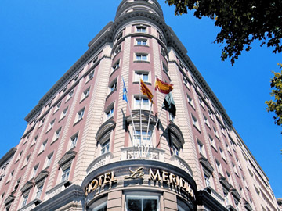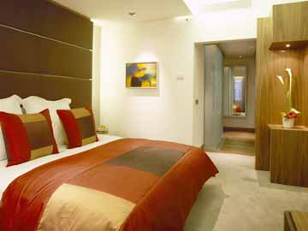

Must-Sees :
Las Ramblas :
A vibrant and lively promenade in the heart of the city centre, where you will find cafes, restaurants, live performances etc.
Attractions along the Ramblas including live performances, human statue art, artists that will draw your portrait.

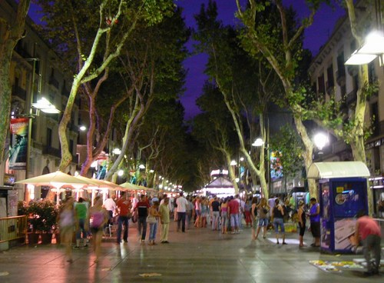

La Sagrada Familia :
A famous church designed by modernist architect Antoni Gaudi. His building designs unusual.
A very unique feature of this church is that its design is based on a Banyan tree.

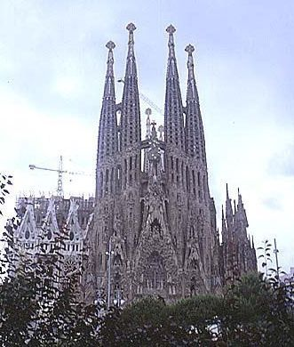

National Palace and Magic Fountain :
This structure that houses the National Art Museum of Catalonia. find exciting pieces from the 19th and 20th centuries and the Gothic Period as well.
The magic fountain consists of a series of cascades and fountains.During the summer evenings, when the fountain is activated, it attracts hundreds of visitors who watch the approx. 15 minute spectacular display of light, water and music. At the same time, the Palau National is illuminated, providing a beautiful background. The show runs every thirty minutes. The start and end date depend on the time of the year, but the best time to see the fountain is at sunset

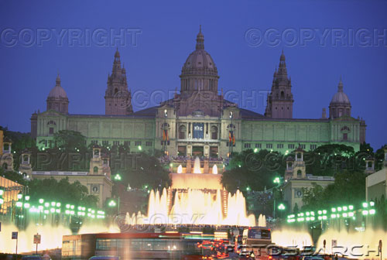

Basilica of Montserrat :
1 hr from Barcelona, half day/fullday excursions are possible to this famous basilica located near the top of the 4,000-foot mountain and is home to the Black Virgin.
It is a small Romanesque statue made of wood. It depicts a seated Black Virgin with the child Jesus on her lap.

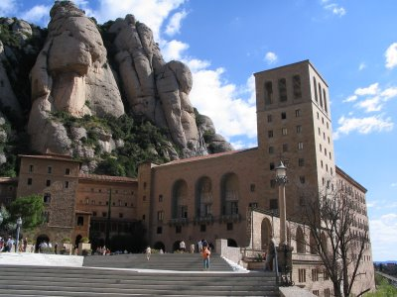

TOLEDO :
Toledo is a World Heritage City as declared by UNESCO. Being close to Madrid, it is an ideal place to visit after Spain’s actual capital city, being only an hour away by land.

It is an authentic Museum city and the medieval capital of of Spain where one can admire the symbolic monuments of the 3 different cultures from the Middle Ages : the Christians, the Hebrews and the Muslims.

Must – Sees :
Museo De Tavera

This is a museum, within a 16th century palace and home to some fine works by great artists like El Greco.
It is unusual because it is still inhabited. Furniture and decor date from the sixteenth and seventeenth centuries, and there are also some fine paintings, including works by El Greco, Ribera and Tintoretto. National Historic Archive records to do with the aristocracy are also housed here. Be patient if the door is not answered immediately. The occupants may have popped down to the shops or be showing other visitors around.

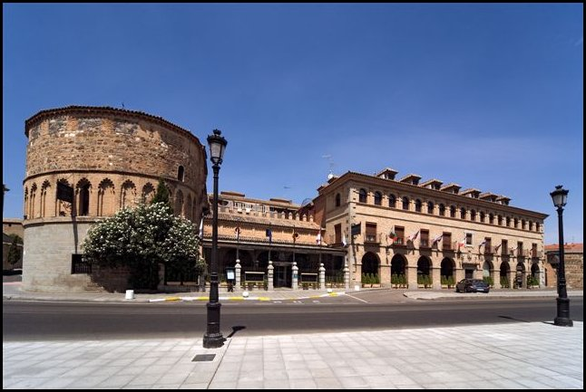

Toledo Cathedral :
It is ranked among the greatest Gothic structures in Europe. Inside, the cathedral contains important masterpieces by artists like El Greco.
The impressive Cathedral of Toledo is a mix of gothic, muddier, baroque and neoclassical styles. It was built in the 7th century and contains paintings from such great artists as Gay, El Ger., Titian, Rebels, and more. It's a veritable holy museum!
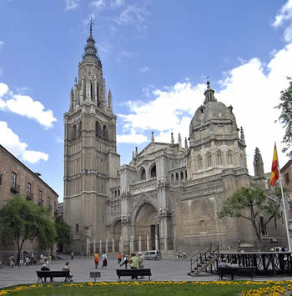

IBIZA :
Ibiza – the famous island is declared a UNESCO World Heritage City. The island is internationally known because of its non-stop party atmosphere. It boasts of one of the best beach towns in Spain, for the niche clientele.

Accomodation Options in Ibiza :
Resorts and hotels are located literally all over the island. Wherever there's a decent stretch of beach there will be a hotel within striking distance of it. The main resort towns are Ibiza Town itself (and beaches nearby such as Cala d'en Bossa - the most famous beach on the island) and San Antonio (on the opposite side of the island from Ibiza Town). These both offer extensive facilities for tourists, with plenty of restaurants and bars.. Both of these are also the areas for the hottest nightlife as well however, so depending on what you want from Ibiza they might not be ideal. San Antonio in particular can be a bit much for older tourists or those seeking a relaxing holiday.
Around Ibiza Town you'll find a full range of hotels, from basic self-catering apartments to four-star hotels such as the Los Molinos, located close to the town but is surrounded by its own gardens, creating an air of seclusion somewhat difficult to find at times on Ibiza. Boasting a spa and fantastic seaviews it is a good choice for discerning holidaymakers.
In San Antonio, try Bellamar Beach and Spa, which is conveniently located opposite Es Pouet Beach and is well equipped with outdoor pool and spa facilities.
Other towns around the island where hotels are clustered include Es Cana and Santa Eulalia (both north-east of Ibiza Town) and San Miguel to the north of the island.

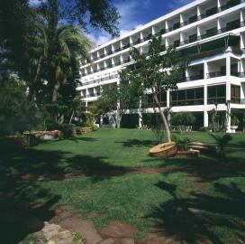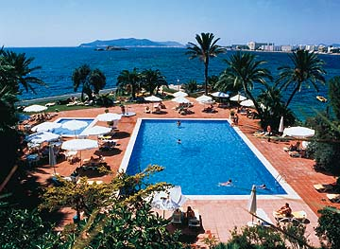

Must – Sees :
Ibiza Old Town :
It is classical island Spain, with ancient Arabian-built walls, and steep, cobbled streets creating a multi-level maze. The buildings are remarkably picturesque with traditional tile-roofed houses painted gleaming white where they aren't covered with hanging plants. Enter the town via the Portal de Tablas, a drawbridged entrance built in 1585 in a classical Romanesque style. The cathedral, a simple but imposing structure, dominates the skyline with its single tower, and you should explore its austere interior. Also don't miss the Archaeological Museum, the world's most important collection of Phoenician (Punic) remains (6th century BC). And items are still being discovered. As recently as 2002 a large cache of artefacts dating back to the time of the Moorish occupation were found in a forgotten room of the castle, while on the "hill of windmills" an ancient cemetery has been unearthed.

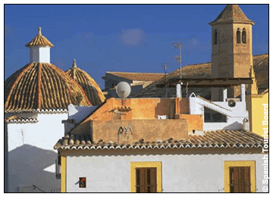

San Antonio :
San Antonio bay is probably the most beautiful on the island.
A palm tree lined boulevard along the sea front has been built (check out "Columbus's Egg" the modern art sculpture situated here - the explorer is contentiously claimed to have come from Ibiza) which is very pleasant, and a number of squares and fountains add to the contemporary feel.
The marina is home to rich people's playthings, while the hoi polloi catch the ferries from the harbour to any of several beaches in the vicinity. Of course San Antonio comes into its own when the sun goes down. As well as the nightclubs there is an incredible range of bars and restaurants that serve the wandering crowds of young northern Europeans (mainly British but also Germans and Scandinavians) late into the night .

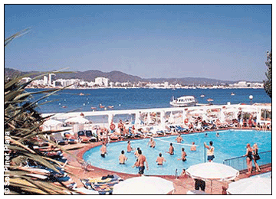

Diving and Other Water Sports :
The clean, warm waters that surround the Balearics are ideal for a range of watersports. The clarity of the water makes them a favourite among scuba divers in particular, but keen windsurfers, water skiers and sailors also come here (and that's not counting the thousands of people who try jet biking, para-sailing and inflatable rides from the beach during their stay). Alternatively the Phoenix Dive Centre at Delfin Beach, and Rumbo Azul (located at three resorts) are two of the island's best-known operators and will escort anyone from a complete beginner to a veteran to any of Ibiza's fabulous off-shore dive sites.

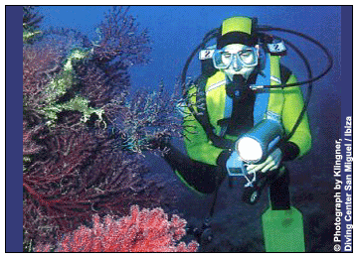

Dolphin and Sealife Cruises :
Ibiza is a great destination for spotting everyone's favourite aquatic animal - the dolphin. Any marina on the island will have at least one operator offering dolphin or wildlife spotting cruises, lasting anything from an hour to a half-day outing. You have to leave the coast to stand a chance of seeing a dolphin - they rarely come close into the shore, so you are unlikely to see one on a jaunt into the next bay, but any cruise that heads a bit further out is likely to attract a couple of the playful creatures. You also stand a fair chance of seeing turtles and medium sized sharks (blues are most common) in the summer.
You can either charter your own boat with friends or find a larger cruise vessel. Your hotel might be able to help you if you can't find anything suitable leaving from the public harbour.

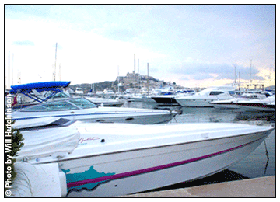

SEVILLE :
Seville, is the capital of the Andalucian Region and is one of the most loved places in Spain.
This place boasts of 3000 hours of sunshine per year! It is one of the most exciting cities in
Spain, with wonderful parks and gardens, Muslim monuments, flamenco dances, bullfights.
Seville is the city of orange trees, they grow everywhere and start bearing fruit in Spring.

It is famed for its good food like the famous snack-like servings (tapas) and other local specialities.

Accomodation Options in Seville :
The very best of Seville is located around the cathedral and this is naturally where most visitors to the city will want to stay, within easy walking distance of all the central attractions. The popular quarter of Barrio Santa Cruz is also a great area if you're exploring for a hotel at random.
Another convenient area to stay is around the Santa Justa station. This might not sound all that salubrious, but in fact there are some nice hotels in the streets emanating from the station, including the impressive Occidental, which provides very comfortable accommodation in elegant surroundings. The Vertice here is a modern but impressive four-star option in the same area. From either hotel the old town is just a ten minute walk away.
One word of warning if you're planning a trip to Seville. Make sure that you check the upcoming events. During the two big festivals of Semana Santa and Seville's April fiesta the city becomes extremely crowded and you'll be lucky to get any accommodation at any price unless you book well in advance.

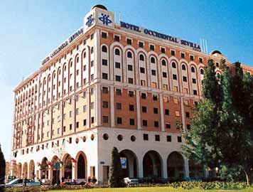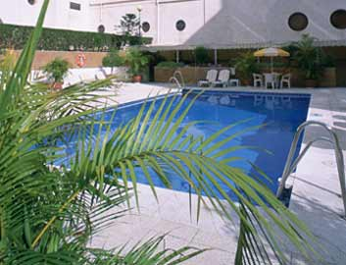

Must – Sees :

The Alcazar (Royal Palace) :
The Alcázar of Seville is a royal palace in Seville, Spain. Originally a Moorish fort. On of the best examples of Islamic architecture, a style under Christian rule in Spain

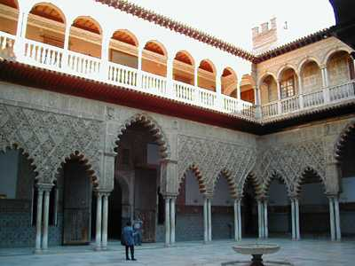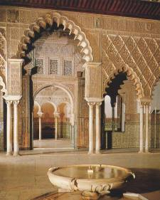

Santa Cruz Quarter :
Here you are in the heart of Seville with its flowery patios, courtyards, and lively squares.

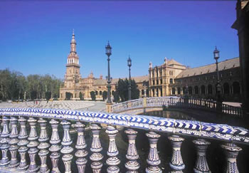

Giralda Tower :
It is the 3rd largest Christian temple in the world. The Giralda Tower was originally a Moorish mosque that preceded the cathedral.
The Giralda is one of the most magnificent buildings in Seville and dominates the skyline. You can ascend to the bell chamber for a remarkable view of the city.
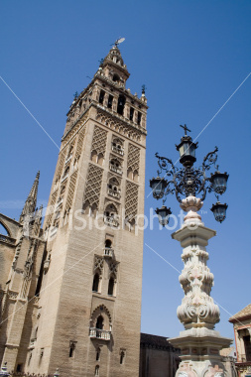

CORDOBA :
This ancient city, which has been declared a World Heritage Site, is a living legacy of the diverse cultures that settled in it throughout history. It was one of the important capitals of of the most powerful kingdom in Islam in the 11th century. It is one of the most attractive destinations in southern Spain and boasts of an extraordinary monumental heritage, with its alleys, lanes and gardens.

Must – Sees :

Medina Azahara :
An ancient man made city built from scratch in Western Europe , and one can visit the palaces and museums there.
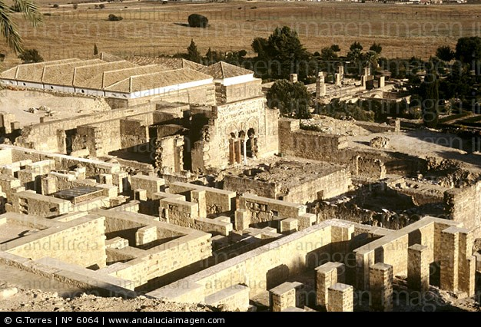

Mezquita :
The Mezquita (Spanish for "Mosque) houses a beautiful mosque and cathedral during the 8th century.The Mezquita de Cordoba is most notable for its giant arches and its forest of over 1,000 columns of jasper, onyx, marble, and granite. These were made from pieces of the Roman temple which had occupied the site previously, as well as other destroyed Roman buildings.
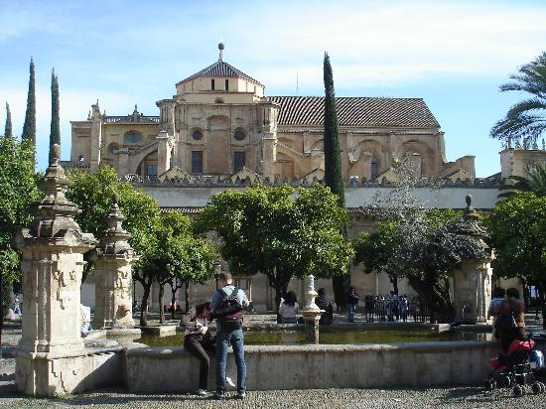

GRANADA :
Located at the foot of the “Sierra Nevada”, Spain’s highest mountain, Granada is considered to be one of the pearls of Spain. It is the capital of Spain’s last Moorish Kingdom.
This long time capital of Moorish Andalucia showcases “The Alhambra” which is the most visited monument in Spain.

Must – Sees :

Alhambra Palace :
The Alhambra is one of the greatest masterpiece of Islamic art and architecture.
It is famous for its fortress, palace, patios and gardens.
There is the Generalife - the summer palace of the sultans, set in the soul-soothing Alhambra gardens.During the period of Muslim domination of Spain, Granada was the finest city on the peninsula. Today it is still home to the greatest Muslim legacy in Europe, and one of the most inspiring attractions on the Continent - the Alhambra.
and is simply breathtaking. Much has been written about the fortress, the palace, its patios and gardens, but somehow nothing can really prepare you for it. The Alcazaba is the Alhambra's Muslim fortress dating from the 11th century, with great views of the city from the tops of its towers. The Palacio Nazaries is the centrepiece of the Alhambra, and is noted for the intricacy of its stonework.
Open: daily 08h30-20h00 (Mar-Oct); 08h30-18h00 (Nov-Feb). Night Visit: Fri & Sat: 20h00-21h30 (Nov-Feb); Tue-Sat 22h00-23h30 (Mar-Oct ). Admission: EUR10 (gives you access to the Alhambra, the Alcazar and the Generalife - see below)

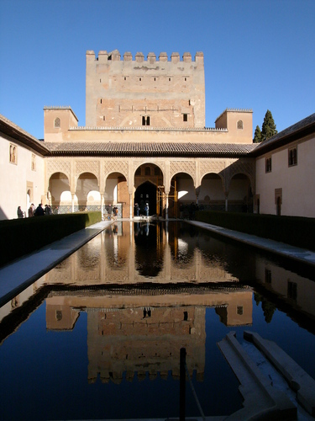

Sacromonte :
Visit the famous “cuevas” caves in the mountains of the monastery town of sacromonte, where some of the gypsies still live.
(The Sacromonte hill, which overlooks the city from the North, is famous for its cave dwellings, once the home of Granada's large gypsy community)
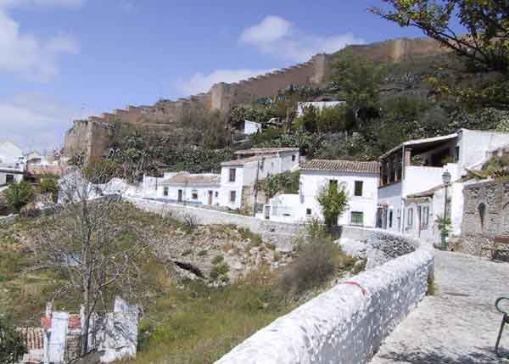

Arab Baths :
A very popular pastime during Roman and Arabic cultures was to visit the public baths and relax in the warm water and recharge your batteries. This custom has been revived. The baths have a very relaxing environment and background music, suitable for families. The facilities include: A recepetion area, a dressing room, showers, a hot water pool at 39ºC and a cold water pool at 20ºC..

Prices are approx:
Use of baths: 16 euros (90 minutes)
Use of baths + massage + aromatherapy 25 euros (Massages last 15 minutes)

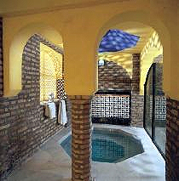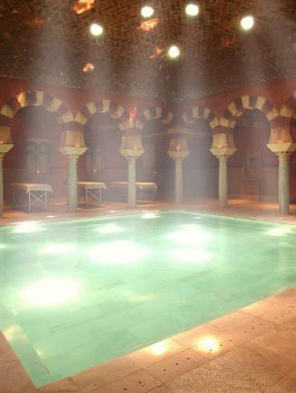

MALAGA :

Malaga is the Capital of Costa Del Sol and one of the most visited regions in Spain. It is the birth-place of Picasso, the great artist. Visit Ronda – the oldest village in Spain with the oldest bullring. Marbella in Southern Spain is ideal for upscale trips and home place of many famous people and wealthy families.

Accomodation Options in Malaga :
The closest resort to Malaga, just a few minutes from the airport, is Torremolinos where the local government has done a lot in recent years to kerb the resort's wild image and convert it into a more family orientated place. Marbella, further down the coast, and Nerja, on the other side of Malaga, are a little more difficult to reach by public transport and consider themselves up-market resorts with the higher prices to prove it.
Within Malaga city itself, many hotels are situated around the historical old port, near the Alcazaba and 16th-century cathedral. The Malaga Centro is situated in the heart of the city and is a modern hotel that neighbours a residential district. A few blocks removed from the beachfront it's a good choice if you don't mind a short walk to the entertainment and prefer a bit of piece and quiet of an evening. The Las Vegas, just outside the town, is more typical of the hotels in the area, fronting onto a beach and within walking distance of the town and its attractions. With a pool and lounge area it's a comfortable place to stay whether for a few days or a week or two.
As capital of the Costa del Sol, Malaga is a popular year-round destination with a range and availability of hotels to match. The airport is only a few minutes' drive from the city centre making transfers extremely quick, and relatively painless.
The busiest time of year is Jul-Oct when booking ahead is well advised. Easter and New Year are also popular times for visitors as people escape to the sun.
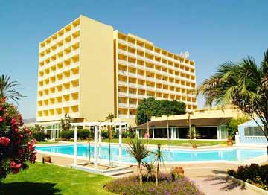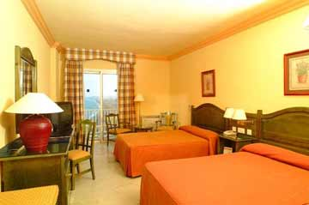

Must – Sees :

Picasso Museum :
The museum houses a variety of artworks created by the great artist and also various canvases by artists who were inspired and influenced by him.

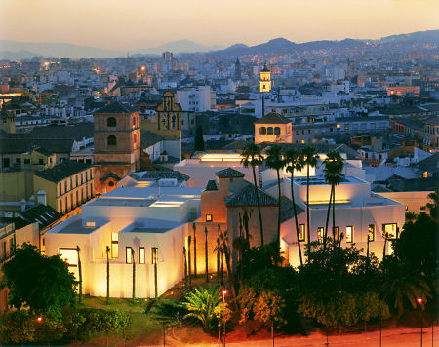

Gibralter :
The colony of Gibraltar marks the Western end of the Costa del Sol - and the Western end of the entire Mediterranean Sea and is important because of its strategic location.It's tiny - only about 4km long - and dominated by the famous Rock of Gibraltar. The rich history of this region is dominated by its, which has been of great importance to Phonecians, Romans, Castilians, the Moors, the Spanish themselves, and currently the British, who have ruled here for almost 300 years. Attractions include the awesome Cave of St Michael, the Apes Den (half way up the rock) and the 12th-century Moorish castle.

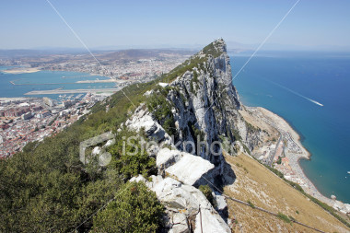

Marbella :
The "International City of Tourism", The chief attraction of this Costa del Sol resort town is, of course, the beaches and its nightlife and entertainment.

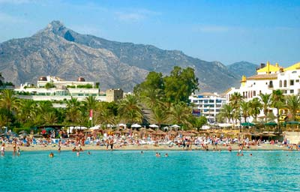

Ronda :
Is a charming village known for its impressive stone structures and depicts architecture with buildings dating back to the time when the region was in the control of the Arabs.In the area between Malaga, Algeciras and Seville is the visually dramatic town of Ronda.This Andalucian mountain village is divided by an enormous 130m-deep river gorge, bridged by an impressive stone structure. The charming village complements this impressive feat of engineering.

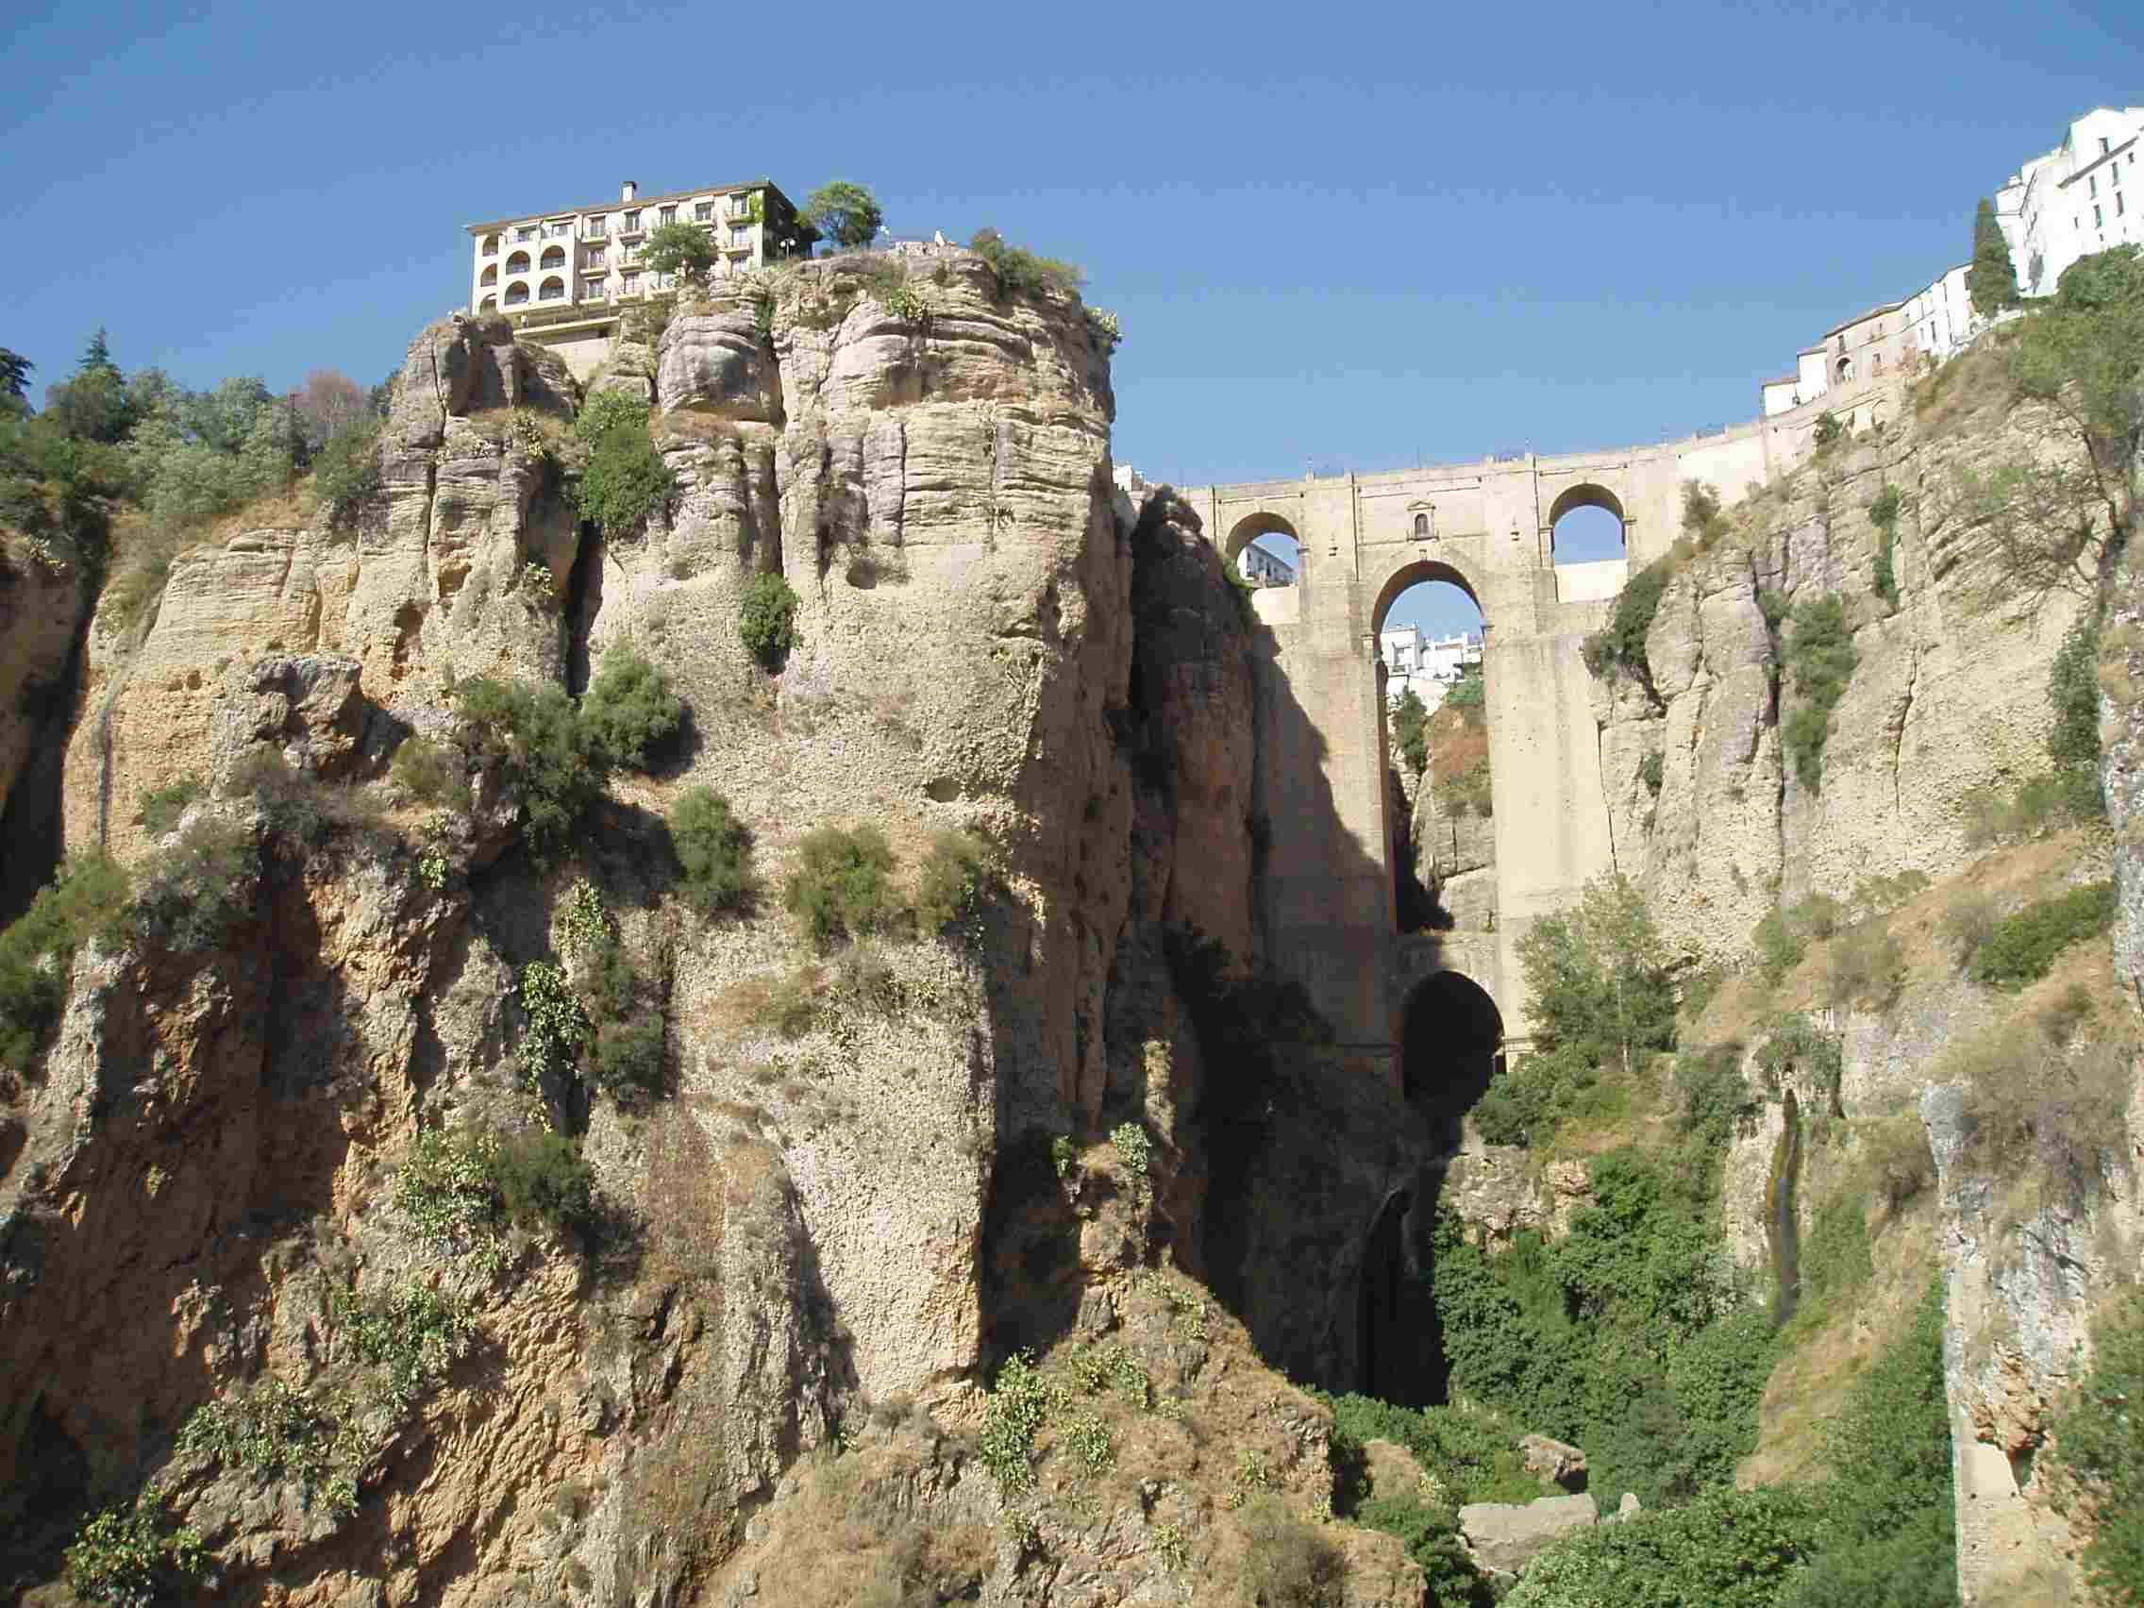

ALICANTE :
Alicante, or "Alacant", is the capital of the region also called Alicante in the Community of Valencia, and has become one of the most popular resort towns on Spain's Costa Blanca, but don't let that put you off.

Accomodation Options in Alicante :
As with most Costa Blanca destinations, many people arrive having already booked accommodation, and most get here on package deals. Consequently, during summer months, Alicante is packed to the rafters with holidaymakers.
However, the town is long used to this seasonal influx and can fit in all of its visitors somehow. Thus, for people booking their own accommodation, there is rarely a problem getting a hotel room.
At the thinner end of the accommodation market in Alicante, have a search around the lower reaches of the Barrio. Apartments in this part of town might not be of outstandingly high quality but are likely to be in more traditional buildings.
North of the town centre, there are many large hotels located along the Playa de San Juan, and this is where more than a few visitors will end up staying, a stone's throw from the sea, and within stumbling distance of a nightclub, restaurant and a pub or two. Try the Castilla, which is only a short walk from the beach. If you want to be in the city centre, head for the Goya, which is situated in the shopping area of Alicante, a great location in close proximity to both the beach and leisure facilities.
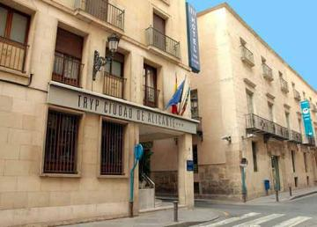
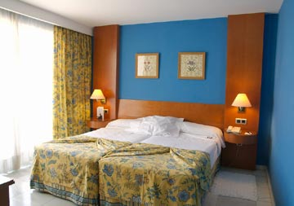

MUST – SEES :

Santa Barbara Castle :
The whole of Alicante is dominated by its 16th-century stone fortress that sits atop Mount Benacantil above the city.
The castle grounds are home to the Capa Collection, the largest collection of contemporary Spanish sculpture in the world. Among the hundreds of pieces on display are originals by such luminaries as Salvador Dali, the famous surrealist.
The fortress is also the best place for views across the city and the bay beyond. You can walk up, or take the lift.
Castillo de Santa Bárbara. Open: daily 10h00-20h00 (Apr-Sep); 09h00-19h00 (Oct-Mar). Admission: EUR2.40.

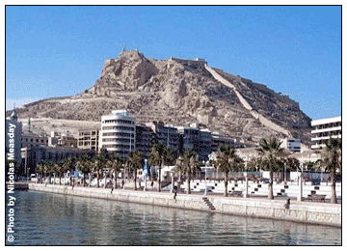

Cathedral of St. Nicholas of Bari :
In the centre of El Barrio is Alicante's spectacular cathedral, Catedral San Nicolás di Bari, built between 1616 and 1662 and restored in 1936. The style of the building more or less defines what is meant by Spanish baroque architecture, with the interior chapel of communion considered to be a particularly fine example of the period.
The central dome is beautifully proportioned, and the galleries are also well worth a look. St Nicolás is the patron saint of Alicante, which might go some way to explaining why such time and expense was taken over the cathedral.
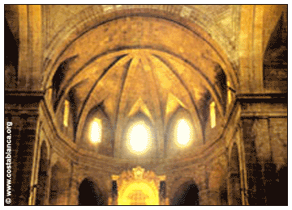

Tabarca Island Reserve :
Several nautical miles from Alicante's coast, Tabarca is the only inhabited island in the Valencia region and is designated a natural monument and island reserve. Surrounded by the azure seas of the Mediterranean it is an idyllic island oasis, and the protected waters around it are home to large populations of marine life. The island is particularly popular with divers who use it as a base for various expeditions. Famously, it is reputed to be the lair of pirates who preyed on boats sailing down Spain's Mediterranean coast.
Now you can explore its surviving fortifications and 18th-century church as well as the castle of San José. Boats to the island leave from the Explanada de España regularly in summer, weather permitting.
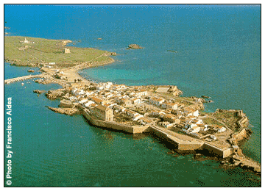

FOOD :
The range and quality of Spanish food is one of the highlights of a visit to the country. Spain is also one of the most pleasant places in which to eat - restaurants are mostly relaxed and friendly. Eating out is a daily treat for the Spanish and their guests alike.
One of the best ways to sample the food is to eat tapas. Rather than buying a starter and a main course, you get lots of small dishes which everyone at the table shares. Just about anything you could want to eat is available as a tapas dish - including meat, seafood, potato and rice dishes and vegetables.
INDIAN RESTAURANTS :

BARCELONA :
Govinda Randhurg
Plaza Vila de Madrid 4, Barcelona
Tel : 93 318 77 29

Taj Mahal
La Rambla End , Near to Port Vell Corner Ra Lambla, Barcelona

Moti Mahal
C/ Sant Pau 103, Bazrcelona
Tel : 93 329 3252

MADRID :
Adrish
Calle San Bernardino 1, Madrid
Tel : 91 542 9498

Agra
Isabel la Catolica, 9, (Nr Metro Santo Domingo), Madrid
Tel : 91 542 2756

ALICANTE :
Ocean Spice
Apartamentos Costamarina, Local Comercial Nº14, 03189 La Regia, Alicante

Sarita Indian
Bahia Blanca Avendia Del Albir 11, Alicante
Tel : 0034 966864394

COSTA DEL SOL :
Rajdoot Tandoori
Lama de Espinosa, Fuengirola, Malaga, Costa Del Sol
Tel : 3495 246 2910

MALAGA :
Flavours of India
Centro Commercial Shopping, Puerto Marina near Sea Life,
Benalmadena, Malaga
Tel : 952 57 4129

Kon Tiki Indian
Ardales Natural Park, El Chorro, Malaga
Tel: 679 742 761

GRANADA :
Jinnah
C/Casillas de Prats 10, 1002, Granada
Tel : 958 26 48 28

IBIZA :
Curry Club
San Antonio, Ibiza

SHOPPING IN SPAIN :
This pedestrian street goes from Puerta del Sol to Callao Aquare and is probably the most touristic one in Madrid, apart from Gran Via. Here you can find El Corte Ingles, FNAC (books and music) and many clothing, shoes... shops. Even if you don't buy anything is nice to walk around and see people passing by. Beware of pickpockets!!

Jewellery is a speciality, often featuring jet from the Northwest, silver from Salamanca, cultured pearls from Mallorca, and the unique jet and gold damascene work of Toledo's artisans. Clothing and leather goods tend to be good value everywhere.
Antiques can be a good buy, and the bigger towns usually have interesting markets. Wrought iron work can be found in Logroño, Seville and the Balearic islands
There is also excellent quality olive oil and a good range of cheeses to be found throughout the country. The most famous wines are probably the red Rioja and the sparkling Cava. Many of the Valdepenas wines are underrated and of a very high standard.
